Glass Melting
Abstract
In this lab experiment, we prepared different glass compositions and also evaluate the effect of glass modifiers and glass formers on the properties of glass. In the glass-melting furnace, the raw materials are melted up to the desired temperature under a controlled environment. After that melted material is supercooled to avoid crystallization.
Introduction
Glass Melting is an important process for making glass materials. In the glass-melting furnace, the raw materials are heated to temperatures up to 1700 degrees Celsius. The furnaces are large and well-suited insulated vessels. In this glass melting, we used an electric gas-fired furnace. Glass is prepared at a glass transition temperature (Tg). Tg Temperature is a lower temperature than the melting temperature of the glass. crystalline materials have long-range order i.e. repetition of a unit cell. On the other hand, glass does not have long-range orders.
Theory
The constituents of glass are divided into three categories network former, network modifiers, and intermediates. Network former formed the network of chemical bonds and constitutes the bulk of glass. Silicon oxide is the most common network-forming constituent of glass. Glass modifiers are added to glass to change the properties of glass according to different applications. The most commonly used modifiers are lithium, potassium, and sodium. Network modifiers create non-bridging oxygen NBO and cross-linking is disrupted and structure becomes open, thus changing the properties of materials. These decrease the number of strong chemical bonds and lower the melting point and viscosity. Intermediates include titanium, aluminum, and zinc. These can behave as network modifiers or network formers. Tuned balance of network formers, intermediates, and modifiers to prevent the formation of ordered crystallites within the material. For example, one of the most common glasses, the SiO2 glass, consists of an arrangement of SiO4 – tetrahedra. All properties of silicate melts, relevant to glass-forming processes, depending on the proportion of non-bridging oxygen (NBO) atoms, i.e. oxygen atoms solely bound to a network former cation and bearing a negative charge. The number of bridging-oxygen BO and non-bridging oxygen NBO can be calculated by the following formulas 𝑁𝐵𝑂 + 𝐵𝑂 = 𝐶𝑜𝑜𝑟𝑑𝑖𝑛𝑎𝑡𝑖𝑜𝑛 𝑜𝑓 𝑡ℎ𝑒 𝑔𝑙𝑎𝑠𝑠 𝑓𝑜𝑟𝑚𝑒𝑟 𝑖𝑜n and (𝑁𝐵𝑂 + 1 /2 𝐵𝑂) = 𝑁𝑢𝑚𝑏𝑒𝑟 𝑜𝑓 𝑂𝑥𝑦𝑔𝑒𝑛𝑠 𝑁𝑢𝑚𝑏𝑒𝑟 𝑜𝑓 𝑔𝑙𝑎𝑠𝑠 𝑓𝑜𝑟𝑚𝑒𝑟 𝑖𝑜ns.
Process and calculations
We completed glass formation in 5 steps
Collection of raw materials
We collected these materials, silica sand (SiO2), sodium oxide (Na2O) from soda ash, calcium oxide (CaO) from limestone/dolomite, dolomite (MgO), and feldspar (Al2O3).To avoid the coloring of glass we also used nickel oxide (NiO) as a decolorizer.
Batch Preparation
The raw materials and decolorizer are finely ground in a grinding machine then these materials are accurately weighed according to the required proportion before mixing in the mixing machine then the uniform mixture is obtained in the mixture. This uniform mixture is known as a batch mixture.
Melting in furnace
We added a homogenous mixture to the pre-heated crucible up to half of its maximum capacity. After the added powder is melted, we added more to the crucible until the whole batch is melted. After that molted glass is at rest for 2 hours for refining and homogenizing.
Fabrication and Annealing
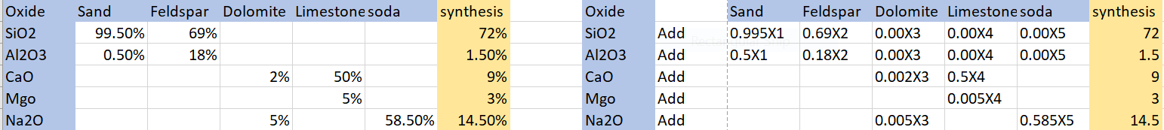
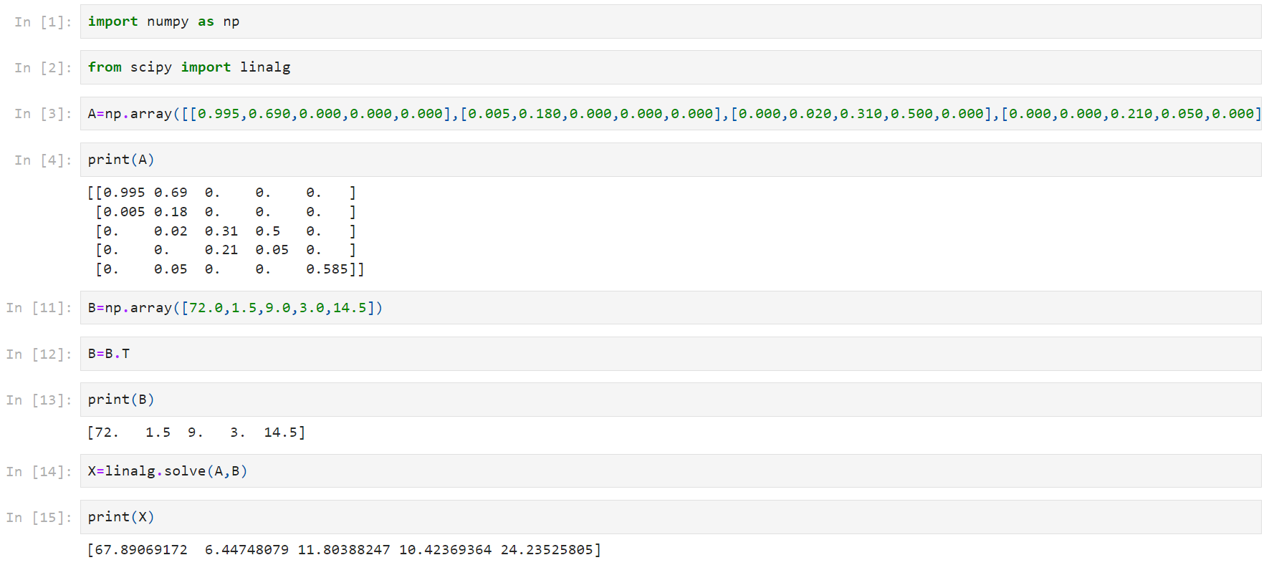
The molten glass is poured into the mold and is allowed to cool down slowly. After that, the glass block is brought to a cooling furnace, set to a temperature around the glass transition temperature (Tg), where it is slowly (6-10K/min) cooled to room temperature.
Further calculation is done using python .Source.Adi_Jupitor_N_Python
Calculated X1=67.89, X2=6.447,X3=11.8,X4=10.42,X5=24.23
Sand=1000g,Feldspar=95g,Dolomite=174g,Limestone=153g,Soda=353g
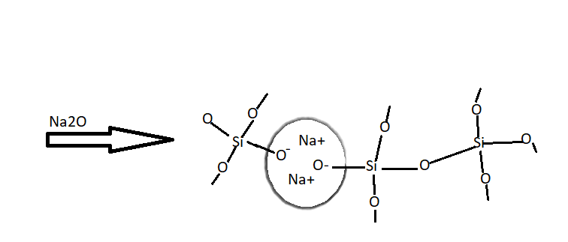
We used SiO2 as glass former ,Al2O3 as intermediate and, MgO, Cao and Na2O as network modifiers.

We will calculate bridging and non-bridging oxygen using the following formulas.
𝑁𝐵𝑂 + 𝐵𝑂 = 𝐶𝑜𝑜𝑟𝑑𝑖𝑛𝑎𝑡𝑖𝑜𝑛 𝑜𝑓 𝑡ℎ𝑒 𝑔𝑙𝑎𝑠𝑠 𝑓𝑜𝑟𝑚𝑒𝑟 𝑖𝑜n
(𝑁𝐵𝑂 + 1 /2 𝐵𝑂) = 𝑁𝑢𝑚𝑏𝑒𝑟 𝑜𝑓 𝑂𝑥𝑦𝑔𝑒𝑛𝑠/ 𝑁𝑢𝑚𝑏𝑒𝑟 𝑜𝑓 𝑔𝑙𝑎𝑠𝑠 𝑓𝑜𝑟𝑚𝑒𝑟 𝑖𝑜ns
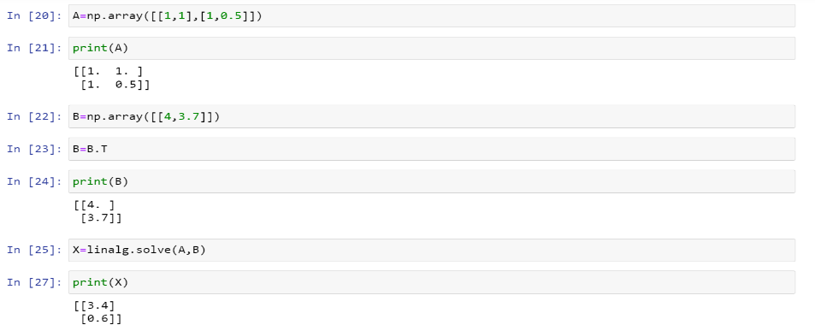
Co ordination of glass former ion=4,number of oxygen=11,number of glass former ions=3
Source=Adi_python_BO_NBO_Calculation
NBO=3,BO=1 for long range order.
Annealing temperature should be around Tg because internal stress minimize at this temperature but if we suddenly reduce the temperature, the glass will becomes more rigid without minimizing the internal stress and the result is very brittle glass that is prone to shattering,the process of annealing helps the manufacturer to eliminate the internal stress.
References
1. T. Tam, A. Bhatnagar, in Lightweight Ballistic Composites (Second Edition), 2016
2. M. Hayashi, H. Ishii, M. Susa, H. Fukuyama, K. Nagata
Effect of ionicity of nonbridging oxygen ions on thermal conductivity of molten alkali silicates
Phys. Chem. Glasses, 42 (1) (2001), pp. 6-11
3. Anshuman Shrivastava, in Introduction to Plastics Engineering, 2018
4. Lorraine F. Francis, in Materials Processing, 2016
5. H.W. Nesbitt, G.M. Bancroft, R. Davidson, N.S. McIntyre, A.R. Pratt
Amer. Mineral., 89 (2004), p. 878

